LAB EXPERIMENT NO # 08
Name: __________________________________ Date: ________________________
Score: __________________________________Signature of Instructor___________
KIRCHHOFF’S LAWS
PERFORMANCE OBJECTIVES:
At the completion of the experiment the student will be able to:
- Validate Kirchhoff’s current and voltage laws
- Gain proficiency with lab equipment and technique
- Predict the path of current flow using Kirchhoff’s current law
COMPONENTS AND EQUIPMENTS:
- Multimeter
- Power supply
- Connecting Leads
- Breadboard
- Few Resistors
- Ohmmeter
- Voltmeter
- Ammeter
INTRODUCTION:
In 1847, Gustav R. Kirchhoff formulated two laws that have become fundamental to the study of electronics. They are as follows:
- The algebraic sum of the currents into and out of any point must be equal to zero.
- The algebraic sum of the applied source voltages and the IR voltage drops on any closed path must be equal to zero.
At first, Kirchhoff’s laws seem obvious. That is, it seems obvious that whatever goes into a circuit must also equal what comes out of it. However, Kirchhoff’s laws are used to analyze circuits that are not simple series or parallel or series-parallel circuits. For example, circuits that contain more than one voltage source and that contain hundreds of transistors cannot be understood without using Kirchhoff’s laws to analyze those circuits. In its simplest form, Kirchhoff’s current law could be used to analyze the circuit in Figure1.

Simplified Version:
I₁=I₂+I₆ I₂=I₃+I₄ I₅=I₂
I₆=I₁-I₂ I₃=I₂-I₄ I₇=I₆+I₅
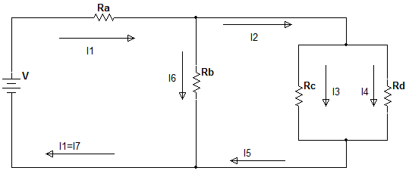
I₂=I₁-I₆ I₄=I₅-I₃ I₇=I₁

Figure 1
Algebraic Version:
+I₁-I₆-I₂=0 +I₅+I₆-I₇=0
+I₂-I₃-I₄=0 I_{T}=I₁=I₇
NOTE: For the circuit of figure1, if V=20V, the sum of the IR voltage drops across the series and parallel combination of R_{a}, R_{b}, R_{c}, and R_{d} will also equal 20V.
Be sure that you understand the algebraic version of the circuit. It has become standard practice to assign positive and negative values to the currents as follows: The current into any point is positive, and the current out of any point is negative. Also, this would be true if there were more than one path for the current to enter or leave. Do not confuse this with electron flow.
Although the circuit in Figure1 is a series parallel circuit, it was used to demonstrate how Kirchhoff’s laws operate. Now consider the circuit of Figure2. This circuit could not be solved for its current and IR voltage drops without using Kirchhoff’s laws because of the two voltage sources.

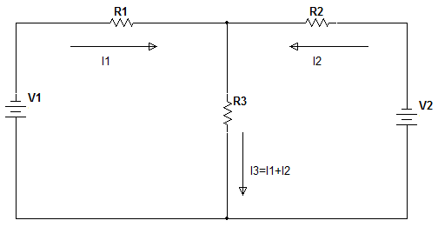

Figure 2
By using the loop method, Kirchhoff’s laws can be used to determine the currents and IR voltages in the circuit by calculation. For example,
For loop1 V₁-V_{R1}-V_{R3}=0
For loop2 V₂-V_{R2}-V_{R3}=0
By following the loop around its path, Kirchhoff’s law provides a method. Take the source as positive, and take the individual path resistance as negative. The sum is equal to zero. This means that circuits will be divided into separate loops as if the other voltage source and its corresponding path did not exist. The IR voltage drops would be calculated as follows.
- VR1=I1R1
- VR2=I2R2
- VR3=I3R3
PROCEDURE
- Make the circuit as shown in Figure 2. Take the resistors that are available in the laboratory upon requirements. Set the value of V₁ and V₂ as 12V and 5V.
- First calculate all the values of V_{R1}, V_{R2} and V_{R3} and I₁, I₂ and I₃ and fill the corresponding Table1.
- Now measure the required values through voltmeter and ammeter and fill the corresponding Table1.
- Repeat the procedure for Figure1 by taking applied Voltage as 15V and taking the resistors values of your choice and availability and fill the corresponding Table2.

TABLE1
VALUE | CALCULATED | MEASURED
I₁ | 8.0 | 1.3%
I₂ | 2.3 | 4.3%
I₃ | 4.0 | 2.5%
V_{R1} | 8.0 | 1.3%
V_{R2} | 5.1 | 2.0%
V_{R3} | 4.0 | 2.5%

TABLE2
VALUE | CALCULATED | MEASURED
I₁ | 6.8mA | 1.5%
I₂ | 4.5mA | 2.2%
I₃ | 2.3mA | 4.3%
I₄ | 2.2mA | 4.5%
I₅ | 4.5mA | 2.2%
I₆ | 2.3mA | 4.3%
I₇ | 6.8mA | 1.5%
V_{Ra} | 6.8mA | 1.5%
V_{Rb} | 4.3mA | 2.2%
V_{Rc} | 2.5mA | 4.3%
V_{Rd} | 1.4mA | 7.1%

CONCLUSION:

Table 1
R1=1k
R2=2.2k
R3=1k
V1=12v
V2=5v

